Community Health Connectors
Measuring Impact Tool

Your name:  Organisation:  Contact details - Telephone:  Email: | Claire Leyland  Starting Well Barnardo’s 0-19  07894803443  claire.leyland@barnardos.org.uk
Title of project/case study: | SEND Parent Peer Support group
Brief summary of this initiative, setting out the context, purpose, main activities and (expected) outcomes: | To provide a safe space for parents of children with SEND to share thoughts, feelings, and concerns, in a child free environment.  Run by volunteers whose own children have SEND and supported by a CHC  The group is run from Brookside Family hub on the 1st and 3rd Wednesday of the month

Which type of activity best describes your case study? (Delete as appropriate)  - Self-directed support or work with individuals  - Service development/redesign or provider development  - Community development/capacity building  - Other (please state) | Community Development – reaching out to the families across the Wyre Forest.  Capacity Building – Sharing this information with other professionals and agencies  Providing a safe space for parents to share the triumphs and tribulations of parenting a child with SEND

Who was involved and what was their role? (Please include data on numbers of participants if available). This might include reference to the involvement of:  - People who use care services  - Families/carers/friends/neighbours  - Managers in your organisation  - Front-line staff in your organisation  - Other staff  - Elected representatives (councillors, MPs)  - Voluntary/community organisations  - Wider stakeholders  - Other. | 1 Community Health Connector and a team of 3 volunteers who share the responsibility to make sure there is always at least 1 volunteer at the session, leading on the discussions. Involving admin team to advertise on Social Media Platforms.  Parents that have attended each session  26.05.21 - 6  16.06.21 -2  07.07.21 -3  21.07.21 -2  01.09.21 -3  In between sessions Email communication is made with any relevant information to the parents who have shown interest in the group.  The email contact list contains 20 parents. There is often communication about how things are at home, school, and family life outside of the session. Many of families have found this contact helpful.

Where did the main initiative come from? What were the main drivers for change? | In the Wyre Forest area, it was identified that there was no support group for families to talk about their experiences of raising a child with SEND. Two volunteers identified that as parents of children with SEND they would have benefitted from having a safe child free space to discuss their thoughts and feelings. The volunteers and a CHC were able to create this safe space.

How does this initiative differ from your previous approach/how did it change existing services? | This is a new group that has not been offered before. This group is purely for parents who have a child with SEND, they do not need to have a formal diagnosis. This group will assist any parent who has concerns about their child and will provide up to date information of other services that can support a family when they begin the journey of diagnosis.

Did you consider the effect on social capital/community capacity from the outset and if so, how did it affect the process? | As a service we are aware of the support required in our local communities, but also the levels of support currently being offered.  This group will establish a robust and resilient support network for the community of parents with children who have SEND.

What was the impact on social capital/community capacity? Did the project increase capacity in communities to promote inclusion and support disabled and older people to live full lives as equal citizens? It would help if you could describe this in terms of:  - Social networks and relationships – the effect on existing community and voluntary groups/networks, or how new ones were developed  - Volunteering, community action and involvement  - Civic engagement/engagement with statutory services. | This support group enables parents of children with SEND to meet other parents who may have experienced similar issues, it enables parents to relate to one another and create a shared voice for tackling inequalities in services therefore promoting inclusion.  Many of the families that attend the group have had poor experiences of getting the right support for their child, many have gained valuable information and are aware of their rights as a parent and those for their child. This group can share their learning to empower other parents to fight for what is needed and legally acceptable to get their child’s needs met.  Volunteer involvement is good in this group, they are experienced in this area.  The group are keen to look at issues relating to SEND and improve access and support to other services for children with SEND.

What was the impact on individuals and service users? It would help if you could describe this in terms of:  - How people used their own resources and time  - How people used or developed their knowledge, skills, and capabilities  - Social life and close relationships  - Quality of life  - Control and choice over care and decisions affecting them  - Feeling valued for their contributions. | Parents encouraged to form new friendships and provide support for one another.  After the first session 5 parents responded to a survey and shared that the group was helpful, informative, and relaxed. They also reinforced that this type of group was much needed.  The group is set up to share information and access other services as and when needed, there will be the offer of talks from other individuals/ services around SEND, EHCP, SEND Framework.  This group is helping to improve the quality of life of its service users by building resilience and a support network of likeminded individuals.  The group will address the issues that parents of a child with SEND may face and share the learning from others. It is important for the families to feel looked after and supported. That regardless of how they are feeling they will be welcomed and supported within the group. It is a safe space to share thoughts, feelings, and challenges.

Impact on commissioning – how is the learning from your project being used to reshape commissioning decisions to support better use and further development of social capital across the whole local authority area? | Ideal opportunity to talk with the families about their experiences, being a parent, whose child has SEND, discuss future ideas, and ask for Feedback.  What would the families like to see in their own areas?  What ideas do the families have?  Discussions about how the group of families can influence change within educational and health services.

Barriers to success/problems – what hurdles did you meet and how were they overcome? It would help us if you could think about barriers, you may have met in the following categories:  - Political  - Cultural  - Managerial  - Bureaucratic  - Resources – financial, physical, time  - Workforce issues  - Partnership issues  - Legislation/legal issues. | Risk assessments were required to safeguard the activity and provide guidelines for the professionals to follow.  Staff safety was important to ensure staff were comfortable with the working arrangements.  Involvement from local community through social media platforms.  Suitability of the chosen venue to ensure that families feel safe to attend,

EVALUATION:
Please give details here of any evaluation you have done of your efforts, including evaluative frameworks and tools that you might be using. | 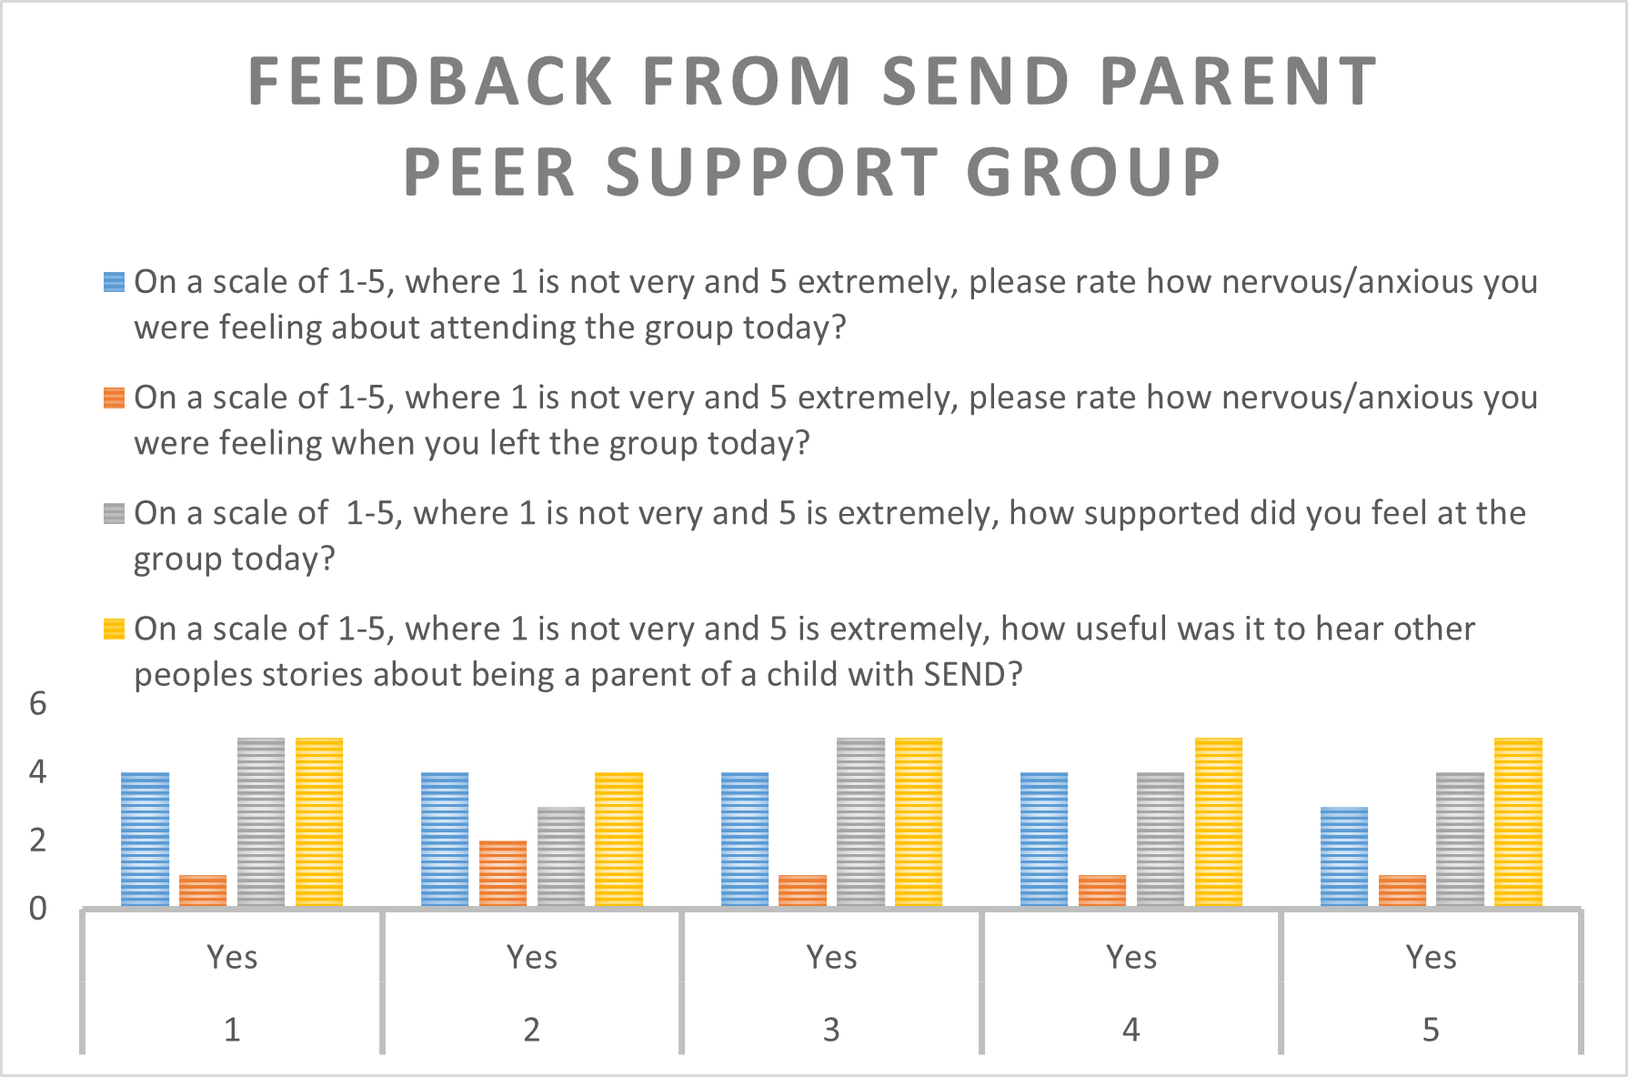
More specifically, what are the expected costs and benefits of these efforts and how far has it proved possible to measure these? | Families feel like they are fully supported by our service. Improved working relationships within our community.  Further signpost families to other groups/activities that are available to them.  Invaluable time spent with these families to have simple conversations regarding how we can support, what ideas do they have?  Benefits also include improved mental wellbeing, healthier lifestyles, and less parental conflict. This will be measured by regular QA feedback to provide qualitative data
Personal comments from those involved. Comments from local citizens, politicians and front-line staff particularly welcomed | Additional Comments received…………  Volunteer quote  “I was so nervous, but I am so happy with how that went, it was amazing, listening to everyone, it really shows how much this was needed.”  Parent Quote  “I have been looking for something like this for years, it can be really lonely and other parents just don’t seem to understand, it is good to meet parents who are going through what I am going through.”  Parent Quote  “it’s a full-time job, I can’t work and make all the phone calls and appointments I need to, maybe in the future when, it calms down hopefully I can. I have to fight to get help with my child, that is a full-time job in itself. Services don’t listen, schools look at him and almost say not my school, just by the look in their eyes. Sometimes I just need to rant, and this group will help with that.”  Parent Quote  “That email you sent me with the therapeutic equine club, was great, my daughter attended during the holidays, and it was so good for her she loved it so much, the impact having a sibling with additional needs has been massive so that course gave her something for her and she thrived.”  Parent quote  “Thank you so much for your email - full of useful resources! This is especially great for me as we have just moved into the area, so I am still learning about what is available locally.”  Parent Quote  “It has been so helpful having this group to talk to about this stuff, it’s like my other friends don’t see it, how difficult it can be, I try to hold it all together, but I don’t need to here. “  Parent Quote  “It has been so good having my partner here today at this group, I know it will help him understand that our child needs to be responded to differently
What advice would you give to an area thinking of trying a similar approach? | Find a suitable location.  Have a clear aim and objective  Advertise in all schools not just specialist provisions
If you could sum up the benefits in one sentence, what would you say? | Gathering a group of Parents together who want to talk about the challenges of being a parent to a child with SEND, encourages honest and frank discussions, enables the group to support one another through the highs and lows, and builds a resilient community of informed and passionate individuals.

